Supplemental Figure 1. Flow diagram of eligible studies selection process

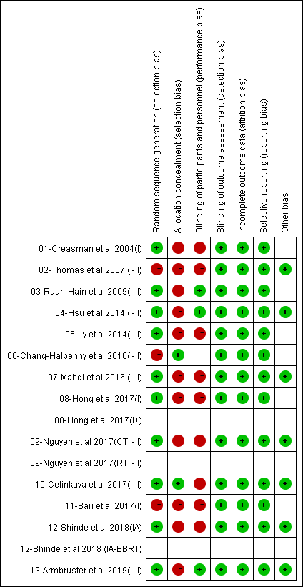
Supplemental Figure 2. Risk of bias summary: review authors' judgments about each risk of bias item for each included study
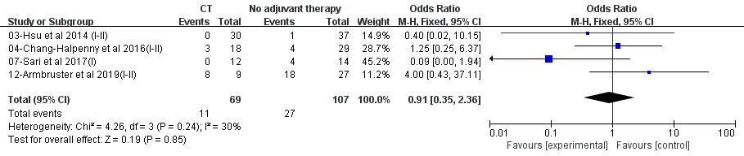
Supplemental Figure 3: Pooled studies of overall survival between patients received CT and no adjuvant therapy.

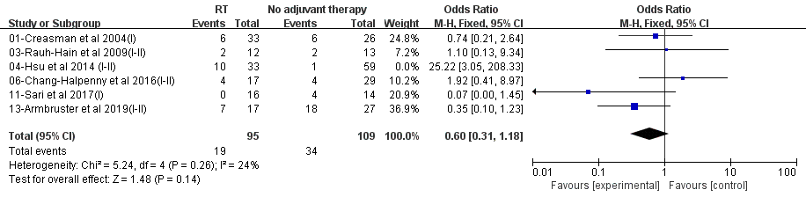
Supplemental Figure 4: Pooled studies of overall survival between patients received RT and no adjuvant therapy.

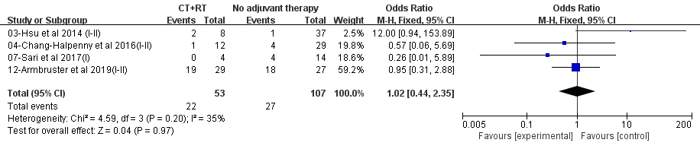
Supplemental Figure 5: Pooled studies of overall survival between patients received CT+RT and no adjuvant therapy.

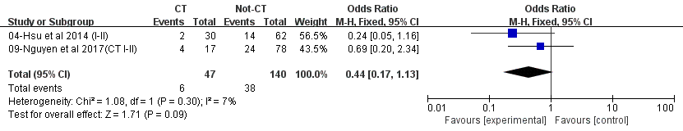
Supplemental Figure 6: Pooled studies of progress free survival between patients received CT and Not-CT therapy.

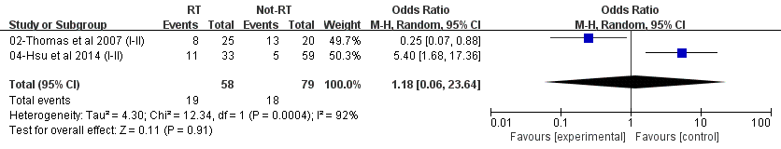
Supplemental Figure 7: Pooled studies of progress free survival between patients received RT and Not-RT therapy.

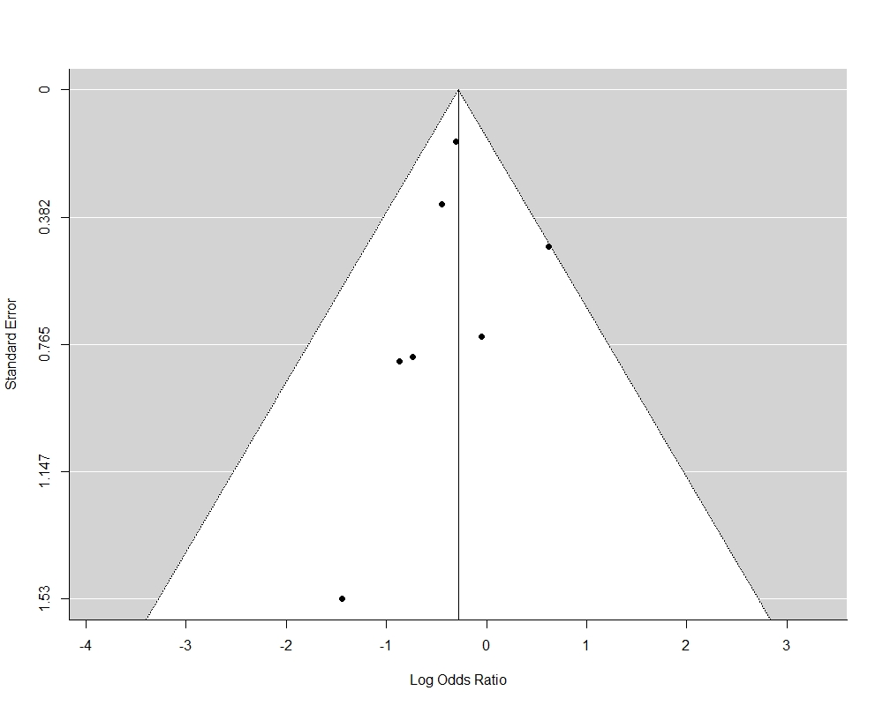
Supplemental Figure 8. Bias assessment plot of studies of overall survival between patients received CT and not-CT therapy.
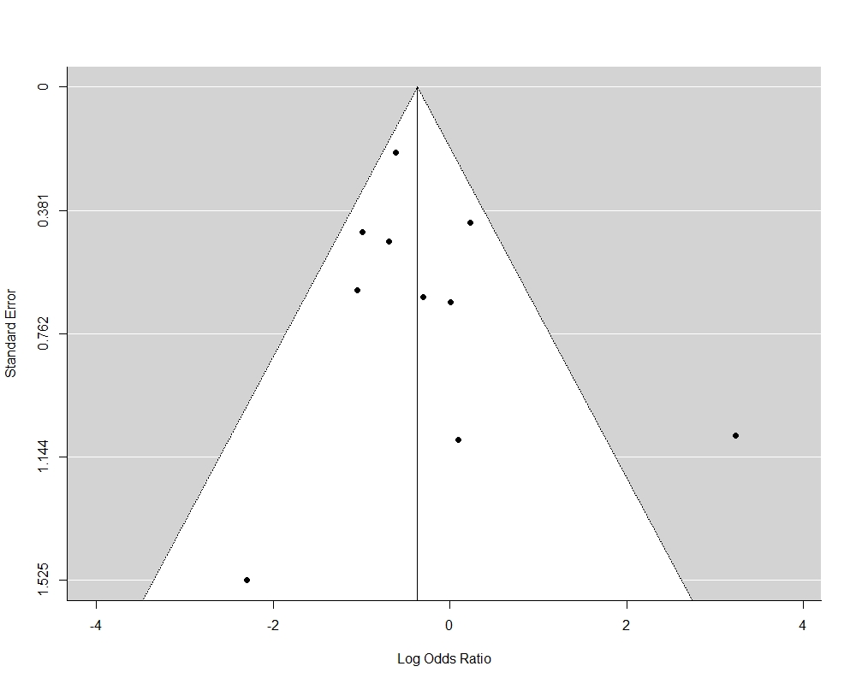
Supplemental Figure 9. Bias assessment plot of studies of overall survival between patients received RT and not-RT therapy.

